**Elian Fernandez, 823256194**

**Project Summary:**

My object code calculator is a perfect substitute for having to pull out your code instead you pull this calculator out and you are able to decipher object code within seconds .

**Hardware:**

* Raspberry Pi
* LCD screen with I2C interface
* Membrane keypad with four buttons
* General Purpose Input/Output (GPIO) pins for user input and LCD control

**Software:**

* Python libraries:
* RPi_I2C_driver: for LCD communication
* RPi.GPIO: for GPIO pin control
* time: for timing operations
* <https://circuitdigest.com/microcontroller-projects/interfacing-i2c-lcd-and-4x4-keypad-with-raspberry-pi-zero-w>
* The above is a link to a guide that i followed which enabled me to communicate with the i2C display using python

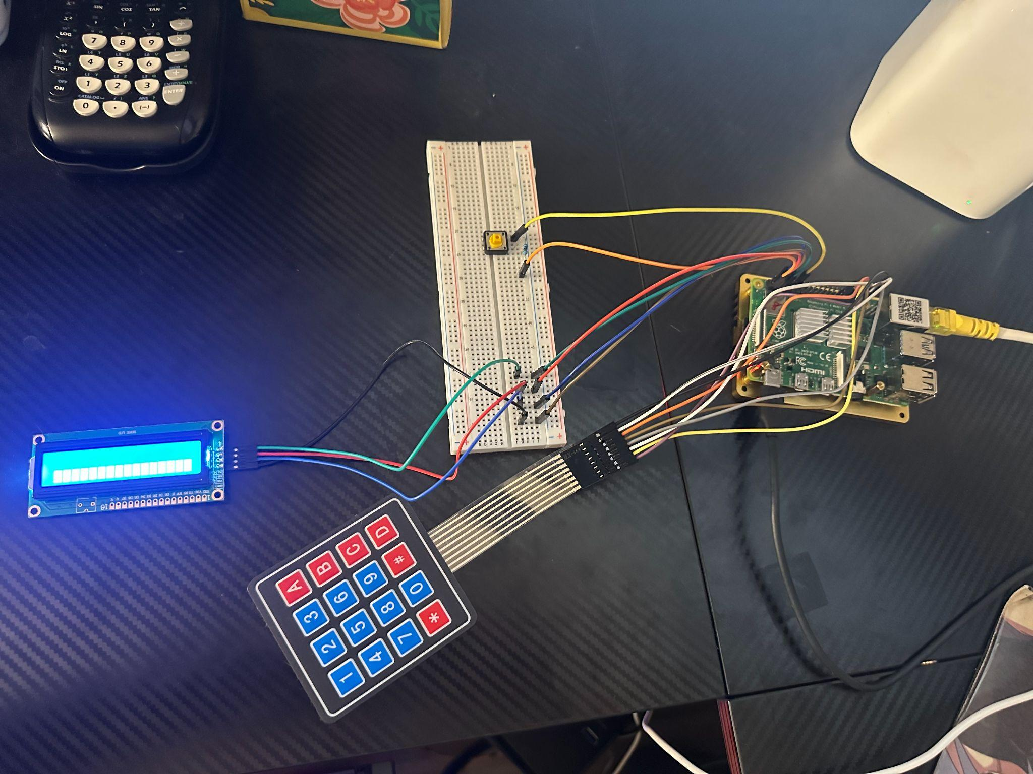

**Input Handling:**

* Accepts user input of object code instructions through sixteen keypad buttons.
* Each button corresponds to a specific hexadecimal digit.
* Users can press a button located on the breadboard to stop further input.

**Data Processing:**

* Identifies the instruction format (2, 3, or 4).
* Decodes the object code and outputs the mnemonic, addressing mode, operand, and format
* Validates the instruction and displays an error message if invalid.

**Output Display:**

* Displays the following on the LCD screen:
* Displays an error message for invalid instructions.
* For format 2 instructions the lcd will display the object code followed by the format on the first row and the mnemonic on the second row
* For formats 3 and 4 the first row of the lcd will display the object code followed by the format “F:” followed by the addressing mode on the second row we will see the mnemonic followed by the operand for the addressing mode

**Diagram**

* This diagram will be necessary for the implementation of the I2C display and the keypad membrane please come back and refer to it in the readme

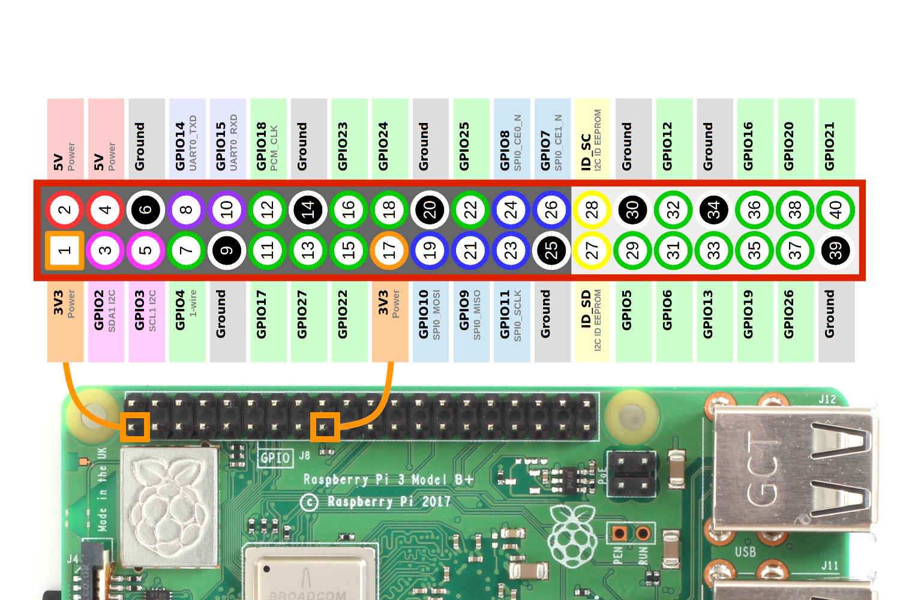

**Video link**

<https://youtu.be/FKI5eifYyJM?feature=shared>